PEP FOR MIMO SYSTEMS

**INTRODUCTION:**

The aim of the project is to simulate a MIMO System that uses a set of Space-time(ST) signals, and using the Maximum Likelihood(ML) decoding to study the relation between the Pairwise Error Probability(PEP) and Signal to Noise Ratio(SNR).

**IMPLEMENTATION:**

1. Consider a MIMO system with *Mt* = 2 transmit and *Mr* = 1 receive antennas. It uses a set of two ST signals:

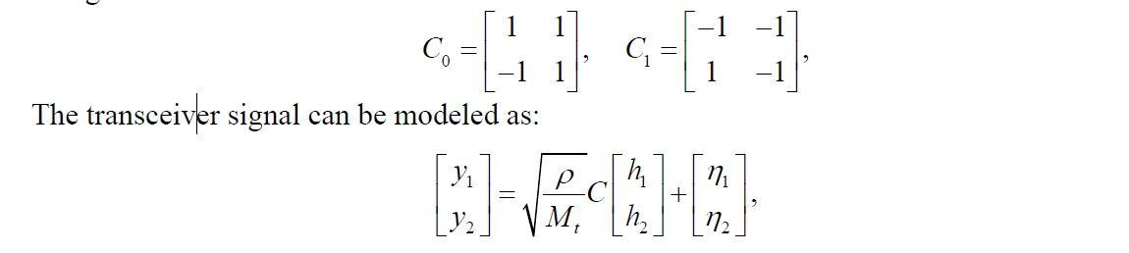

where *C* is either *C*0 or *C*1, *y*1 and *y*2 are received signals at time slots 1 and 2 respectively, *h*1 and *h*2 are channel coefficients from the two transmit antennas to the receive antenna respectively, and η1 and η2 are additive white noise.

2. The channels *h*1 and *h*2 are modeled as independent complex Gaussian random variables with mean zero and variance one, i.e., *CN*(0, 1).

3. The channels are assumed to be quasi-static, i.e., *h*1 and *h*2 do not change in one block (codeword or signal matrix) transmission, and they change from one block to another independently. The noise η1 and η2 are also modeled as *CN*(0, 1).

4. The above system is simulated in MATLAB and the curve of error probability vs

SNR (using the maximum-likelihood (ML) demodulation) is plotted(which is same as the PEP between C0 and C1 in this case).

5. The theoretical PEP between *C*0 and *C*1, obtained by averaging the instantaneous PEP over the Rayleigh fading channels *h*1 and *h*2 is also plotted and the results are compared.

**OBSERVATION:**

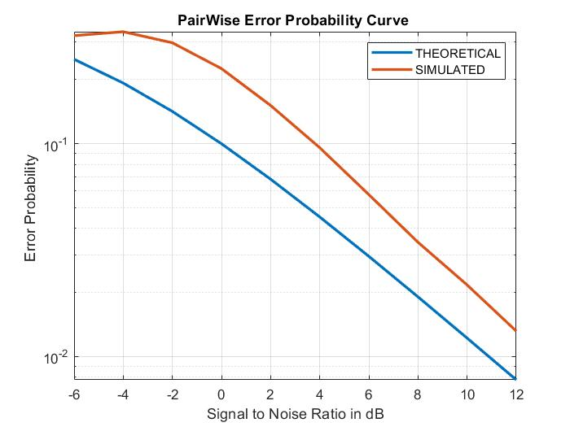

The Figure shows that the simulated SER is not matched, but goes parallel, with the

theoretical PEP from (4). The theoretical PEP is loose, which is due to the approximation

of the Q(x) function that is tight for large x, but loose for small x. We may expect a tighter theoretical PEP if we use a better approximation for the Q(x) function.